3D Data Visualization with Sensor Mapping Express VI
LabVIEW 8.6 introduces a new way to visualize acquired and simulated data in your VIs: 3D sensor mapping. Using a basic Express VI, you can import a 3D CAD model, assign sensors and map DAQ channel data directly onto the model. This exercise will teach you how to use this new feature.

1. Open Sensor Mapping Example.vi, the following front panel and block diagram will appear:
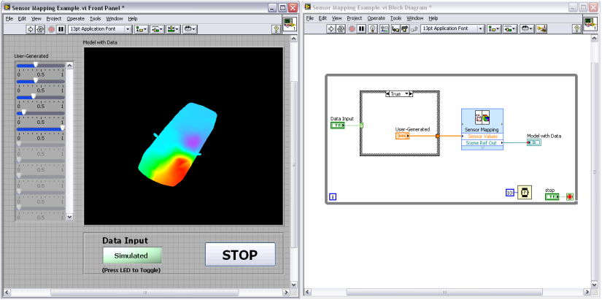
2. Run the VI. By default the VI will use automatically simulated data to demonstrate how a model can appear with dynamically acquired data. Press the LED to toggle between automatically generated values and inputting your own values using the sliders on the left of the 3D picture control.
3. Explore the Sensor Mapping Express VI. On the block diagram, double click on the Sensor Mapping Express VI to open its dialog window.
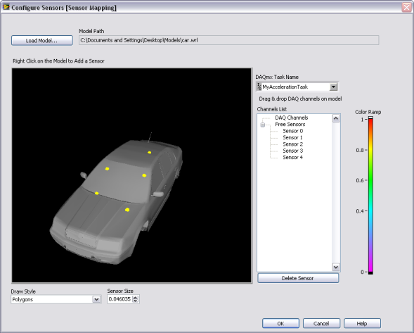
Import a different 3D model by clicking on the “Load Model…” button. Navigate to the Models folder, select a model and press “OK.” The model will now appear in the dialog window. Left-click anywhere in the window and drag the cursor to rotate the model. Hold the Shift key, left-click and drag up or down to zoom in and out. Hold the Ctrl key, left-click and drag to move the model to a new position in the window.
4. Assign sensors to the model. If using actual DAQ hardware, you could create a task in MAX that included your channels and import that into the Sensor Mapping Express VI in the DAQmx Task Name field. This demo only uses simulated data, so you will assign Free Sensors to the model.
Hover the cursor over the location on the model where you want to place a sensor and right-click.
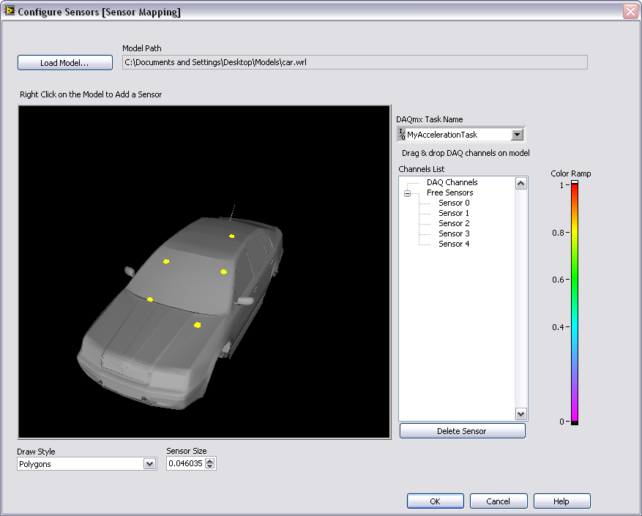
The yellow dot represents the sensor location on the model. Notice that a new free sensor has been added to the Channel List field. You can move the sensor once place by either placing your cursor directly over the sensor, left-clicking and dragging it to a new location; or by left-clicking on the sensor name in the Channel List field and dragging it over to the new location for that sensor.
Sensor size can be changed to scale with different sized models by adjusting the value in the Sensor Size control
5. Place several sensors across the model by right-clicking any where you want a sensor to appear.
6. Press OK once you are finished exploring the Sensor Mapping dialog box.
7. Run the VI again to see the new model you have selected and toggle between automatic data and user-generated inputs.
End of Exercise

